

**Higher National Unit Specification: General Information**

**Statement and Confirmation of Own Work**

**Unit Title: SQL Introduction**

**Unit code: DH3J 34**

**Superclass: CB**

**Publication Date: December 2018**

**Source: Scottish Qualifications Authority**

**Version: 01**

**Student declaration**

I have read and understood SQA HND’s Policy on Academic Dishonesty and Plagiarism.

I can confirm the following details:

**Student ID/Registration number : 1887706750**

**Name :SUAN THIHA NYAN**

**Centre Name : KMD Computer Centre (Yangon)**

**Assessor’s Name : KHIN KHIN LAY KOON**

**Student Signature : Suan**

**Submitted Date : 13-Sep-2018**

Table of Contents

1. Assessment 1 2

1.1. Task (1) 2

Owner table 2

Pet table 4

Practice table 6

Vet Table 7

1.2. Task (2) 8

Visit table 8

Medication table 10

1.3. Task (3) 11

1.4. Task (4) 13

1.5. Task (5) 13

1.6. Task (6) 14

1.7. Task (7) 15

1.8. Task (8) 16

1.9. Task (9) 16

1.10. Task (10) 17

Report 18

**Assessment -1**

**Task-1**

**Owner Table**

(

Owner_ID integer not null primary key,

SurName varchar (50),

ForeName varchar(50),

Gendar varchar (50),

Telephone_No varchar(50),

Address varchar (50)

);

insert into Owner

values (1,'Jackson','Janet','Miss','0141-223321','1.Main Street Glasgow'),

(2,'Singh','Raj','Mr','0141-326535','22.The Hill, Glasgow'),

(3,'Campbell','Bernard','Mr','0143-46523','21,High Street,Glasgow'),

(4,'Hussain','Pauline','Miss','0142-68543','51,Elim Grove,Glasgow'),

(5,'Otten','Gerard','Mr','0141-557536','77,The Walk,Glasgow')

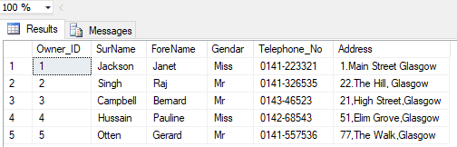 ဘ

Create Table Pet

(

Pet_ID varchar (10) not null primary key,

Pet_Name varchar (30),

Type varchar (20),

Breed varchar(15),

Title varchar(2),

Born int,

Owner_ID integer,

Notes varchar (100),

Foreign Key(Owner_ID) References Owner(Owner_ID)

);

Create Table Pet

(

Pet_ID varchar (10) not null primary key,

Pet_Name varchar (30),

Type varchar (20),

Breed varchar(15),

Title varchar(2),

Born int,

Owner_ID integer,

Notes varchar (100),

Foreign Key(Owner_ID) References Owner(Owner_ID)

);

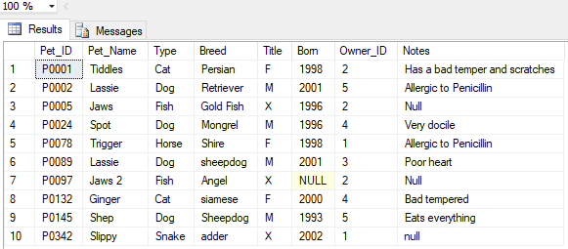

**Practice Table**

I created a table in DataBase,named ‘Practice’.There are three Columns in the table totally.And,I gave the columns names.And, I regarded the datatypes,primary key and the amount of the datatypes.Then,I inputed the data into the table.

Create Table Practice

(

Practice_ID varchar (50) not null primary key,

PracticeName varchar (30),

Practice_Address varchar (50)

);

Insert into practice

values('P1','Practice Head Office','27,The Hill,Glasgow'),

('P2','Practice Unit 1','Unit 1,Houston Estate,Glasgow')

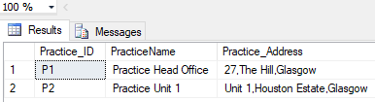

**Vet Table**

At First, I created a table in DataBase,named ‘Vet’.There are eight Columns in the table.And,I gave the columns names.And, I regarded the datatypes,primary key, foreign keys and the amount of the datatypes.Then,I inputed the data into the table.

Create Table Vet

(Vet_ID varchar (5) not null primary key,

SurName varchar(25),

ForeName varchar(20),

Title varchar(5),

Ext_Number int,

Position varchar (15),

Salary Decimal,

Practice_ID varchar(50),

Foreign Key(Practice_ID) references Practice(Practice_ID)

);

Insert into Vet

values ('V01','Wilson','Sarah','Dr','6122','Senior Partner',45000,'P1'),

('V02','McDonald','Bryan','Dr','6154','Senior Partner',35000,'P1'),

('V03','Patel','Jame','Dr','6165','Junior Partner',29000,'P2'),

('V04','McCafferty','Trevor','Mr','6166','Junior Partner',25600,'P2')

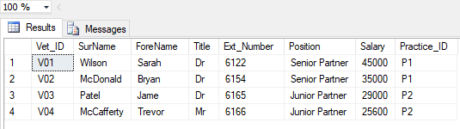

**Visit Table**

At First, I created a table in DataBase,named ‘visit’.There are six Columns in the table.And,I gave the columns names.And, I regarded the datatypes,primary keys,foreign keys and the amount of the datatypes.Then,I inputed the data into the table.

Create Table Visit

(

Pet_ID varchar(10),

Vet_ID varchar(5),

Visit_Date date,

Basic_cost decimal,

Symptom varchar (50),

Treatment varchar(50),

Foreign Key(Pet_ID) references Pet(Pet_ID),

Foreign Key (Vet_ID) references Vet(Vet_ID),

);

Insert into Visit

values

('P0001','V01','04/21/2004',23.99,'Bitten left ear','Injection'),

('P0002','V02','04/21/2004',14.75,'Vomitting','Tablets and Injection'),

('P0001','V01','04/27/2004',20.00,'Bitten right ear','Injection'),

('P0078','V03','04/28/2004',15.00,'Limping','Ointment'),

('P0342','V02','04/03/2004',12.50,'Not eating','Tablets')

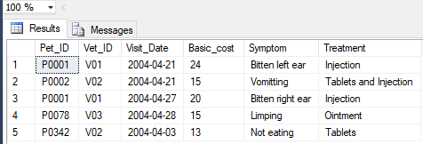

**Medication Table**

At First, I created a table in DataBase,named ‘Medication’.There are six Columns in the table.And,I gave the columns names.And, I regarded the datatypes,Foreign keys and the amount of the datatypes.Create Table Owner

Create Table Medication

(

Pet_ID varchar(10),

Vet_ID varchar(5),

Visit_Date date,

Seq_Number integer,

Medicine varchar (50),

Cost decimal,

Foreign Key(Pet_ID) references Pet(Pet_ID),

Foreign Key (Vet_ID) references Vet(Vet_ID),

);

Insert into Medication

values

('P0001','V01','04/21/2004',1,'Antibiotic injection',12.00),

('P0002','V02','04/21/2004',1,'Stomach Tablets',15.00),

('P0002','V02','04/21/2004',2,'Anti sickness injection',23.50),

('P0001','V01','04/27/2004',1,'Antibiotic injection',16.25),

('P0078','V03','04/28/2004',1,'Soothing Cream',7.99),

('P0342','V02','04/03/2004',1,'Stomach Tablets',12.50)

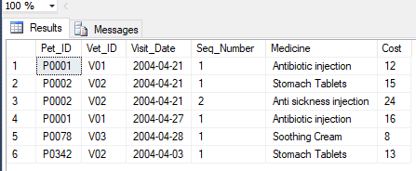

Task 4

I used insert keywords to input the data into the visit table.

Insert into visit

values('P0145','V01','06/22/2004',15.00,'a sore foot','injection and some oinment')



Task 5

I used insert keywords to input the data into the Medication table.

insert into medication

values('P0342','V01','06/03/2004',2,'Antibiotic injection',17.89),

('P0001','V02','07/03/2004',1,'smoothing cream',12.50)



**Task 6**

I droped the table as the task given. It ran successfully.

drop table Practice

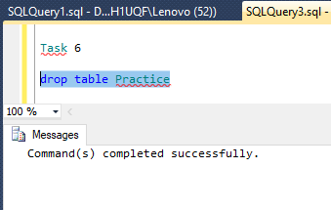

Task 7

The task said that I must delete th column named ‘Practice_ID’.So,I deleted the column and successfully.

Alter table vet

drop constraint FK__Vet__Practice_ID__5AEE82B9

Alter table vet

drop Practice_ID

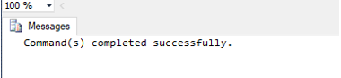

Task 8

As the task requested, I input the new column, named ‘Mobile_Number’.

alter table vet

add Mobilephone_Number varchar(50)

Select * from Vet

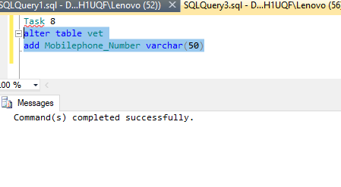

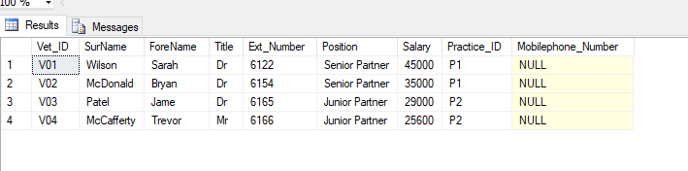

Task 9

The task said that I must put the data into the vet table.So,I used insert keyword to put the the data about the vet table For each of the column.

Insert into vet

values('V05','Junior','Harley Queen','Dr','6168','Senior Partner','58000','P1','01-664747-363'),

('V06','Jones','Wilem ','Dr','6174','Senior Partner','53000','P1','01-546723-865')

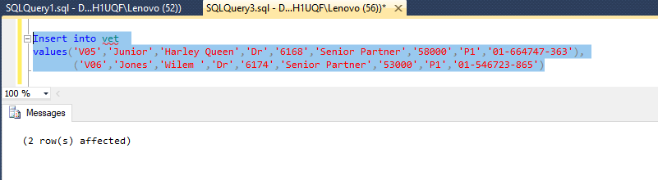

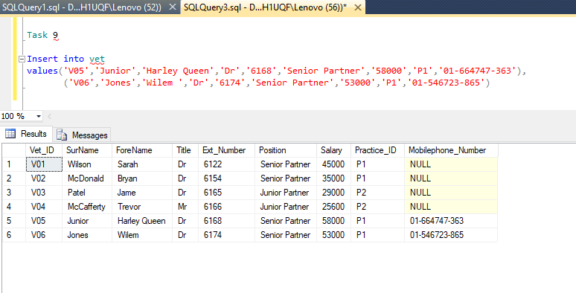

Task 10

As the task requested, I must checked the tables named ‘visit’,’vet’,’medication’.And as a result, the tables are shown that deals with the coding.

Select * from visit

Select * from Vet

Select * from Medication

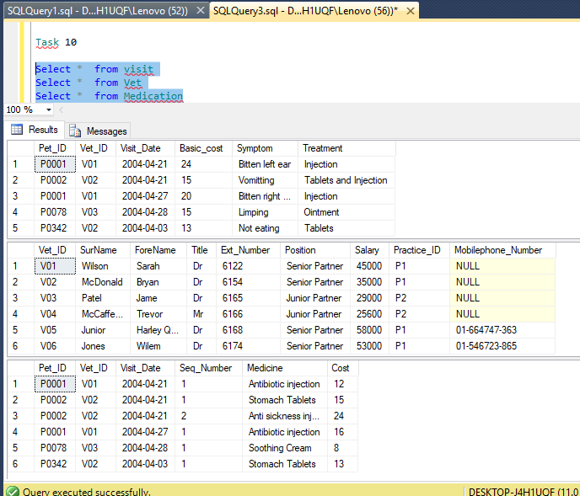

Assessment 2

Task 1

The task said that they want to know the details of the owners and their pets.So, I used the select keyword to pull out the columns that are from the chosen table.By us owners’ names and their pets and made a table.

Select o.Gendar,o.forename,o.surname,p.pet_name,p.type,p.breed

from owner o,pet p

where o.owner_ID=p.owner_ID

order by o.surname,p.pet_name asc

select * from owner

select * from pet

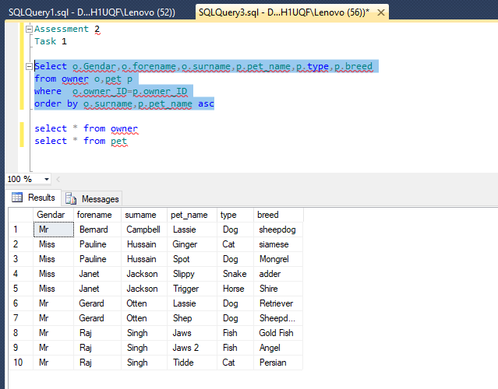

Task 2

It said that they want to know all about the pets that are born between 1999 and 2001.So,I used the ‘Select’ Keyword to find out the pet name, type, breed and born on the table from pet.And I used also ‘Order by’ keyword to see the table in the order of name.And, I used ‘asc’ keyword to see the facts ascendingly.

Select pet_name,type,breed, born

from pet

where born between 1999 and 2001

order by born asc

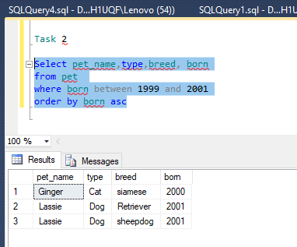

Task 3

The task said that they want to know the numbers of different types of pets.And it said we can ignore whatever there is only one of the type.But, the table should be ordered by the highest occurrences.So, I used the Select word to pull out the facts that deals with the task. And, we checked the condition by using ‘Having’ keyword.And, I used ‘order by’ keyword and ‘Desc’ keyword to arrange the table facts descendingly.

Select count (Type) as Kinds, type from pet

Group by type

Having count(Type)>1

order by kinds desc

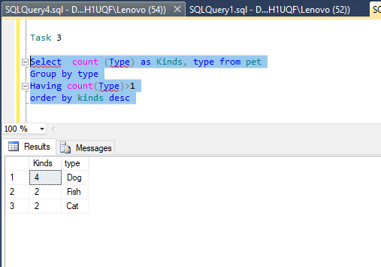

Task 4

As the task asked, we need to find the total salary of the junior partners and senior partners.So, I used ‘Select’ keyword and ‘sum ‘ keyword to see te totoal salary of the the junior partners and senior partners.

Select sum (Salary) as TotalSalary from vet

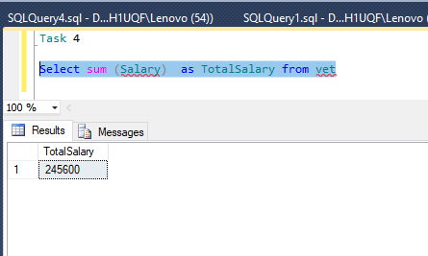

Task 5

We need to make a list of animals which names start with or end with the letter ‘s’. So, I used the select keyword and put the column name into the coding. And ,I used the where keyword to check the condition what I want to list.And, I also used’%’ symbol to search the Nme s start with or end with S.

Select Pet_ID,Pet_name,type,breed,title from

pet

where Pet_name like'%S%' and

title<>'M'

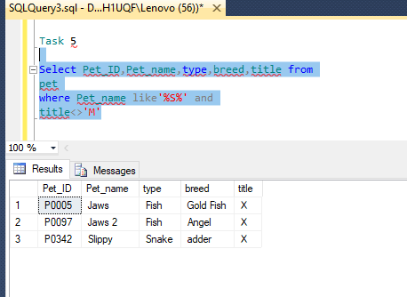

Task 6

I need to make a list that includes all of the visits made by dogs.I used Select keyword to list the column and make a table. And, I also used, where keyword to check the condition of the table. I used order by keyword to arrange the table column ascendingly.

Select p.Pet_ID,p.Pet_name,v.Visit_date,p.breed,v.basic_cost from

visit v, pet p

where p.pet_ID=v.pet_id and

p.type='dog'

order by p.pet_id,v.visit_date

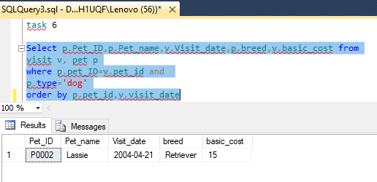

Task 7

I used the select keyword to pull out the column from the original table. And, I used where keyword to check the condition.Then, I used Group by keyword to collect the column that I want to group.And, I used order by keyword to arrange the data in the column ascendingly.

Select v.vet_id,v.Forename+v.surname as FullName,count(vi.vet_id) as No_of_Visit

from vet v,visit vi

where v.vet_id=vi.vet_id

Group by v.vet_ID,v.forename,v.surname

order by Fullname asc

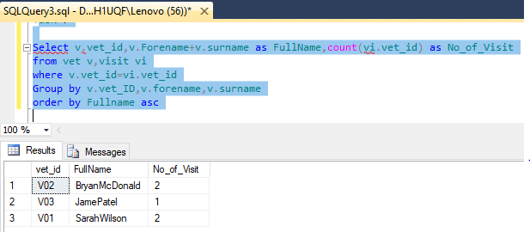

Task 8

I used the distinct keyword to avoid the data duplication from the tables.And, I used the where keywords to check the condition that I want. And I used % keyword to find the word start with or end with ‘ear’ and ‘nose’.

Select distinct p.pet_id,p.Pet_name,p.type,vi.symptom

from pet p,visit vi

where p.pet_id=vi.pet_id

and vi.Symptom like '%ear%'

or vi.symptom like'%nose%'

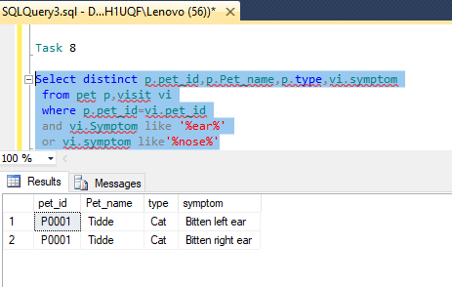

Task 9

I used the select keyword to pull out the columns from the choosen tables. And, I used where keyword to check the condition. And, I used group by keyword to collect the column that I want. I used order by keyword to arrange the rows that are include in the column.

Select v.vet_id,vi.visit_date,sum(m.cost+vi.basic_cost) as totalcost

from medication m,visit vi,vet v

where v.vet_id=m.vet_id

and vi.vet_id=m.vet_id

group by v.vet_id,vi.visit_date

order by v.vet_id,vi.visit_date

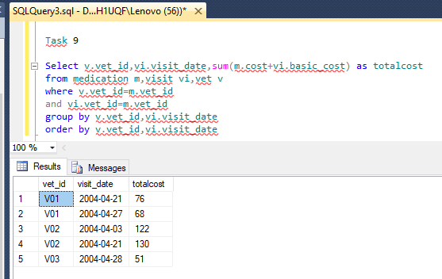

Task 10

I used the select keyword to pull out the column from the chosen table.And, I used where keyword to check the condition of the column that I want. And, I used order by keyword to arrange the column that I want.

Select vi.visit_date,p.Pet_name,p.type,p.breed,vi.treatment

from visit vi,pet p

where p.pet_id=vi.Pet_id and

vi.visit_date between'05/01/2004' and '05/31/2004'

order by vi.visit_date

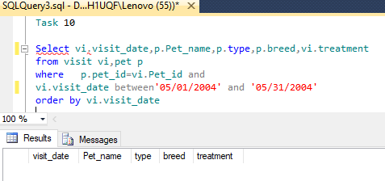

Task 11

At first, I used the select keyword to pull out the columns from the choosen tables.I used avg keyword to know the average of the basic cost. And , I used sum keyword to know the addition of the basic cost. And, I used where keyword to check the condition. And, I used group by keyword to collect the column that I want. I used order by keyword to arrange the rows that are include in the column.

select p.pet_name,p.type,sum(vi.basic_cost) as totalcost ,avg(vi.Basic_cost)

as avgcost,Max(vi.Basic_cost) as Maxcost

from pet p,visit vi

where p.pet_ID=vi.pet_id

and p.pet_name='Tiddles'

group by p.pet_name,p.type

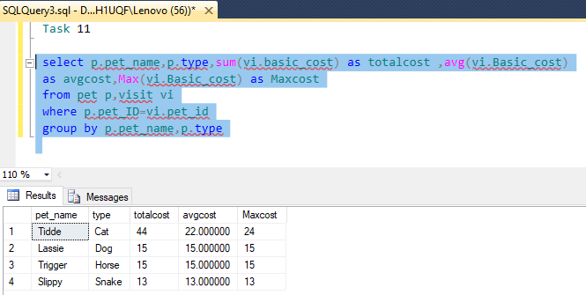

Task 12

I used select keyword to pull out the column from the chosen table.I used the distinct keyword to avoid the data duplication from the tables.And, I used the where keywords to check the condition that I want.And, I used order by keyword to arrange the data that the task requested.

select distinct p.pet_id,vi.symptom,vi.visit_date,vi.treatment,m.medicine

from pet p,medication m,visit vi

where p.pet_id=vi.pet_id and

vi.pet_id=m.pet_id and

p.pet_id='P0001'

order by p.pet_id,vi.visit_date

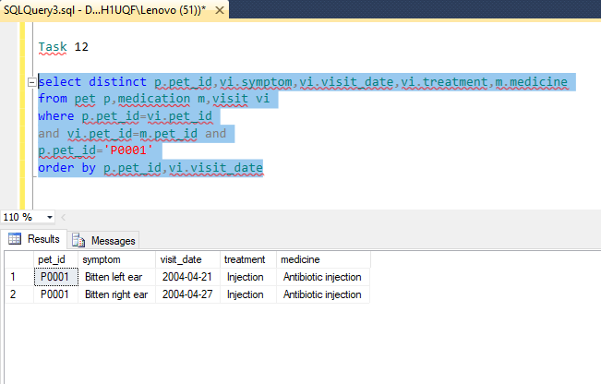

**Assessment 3**

**Report**

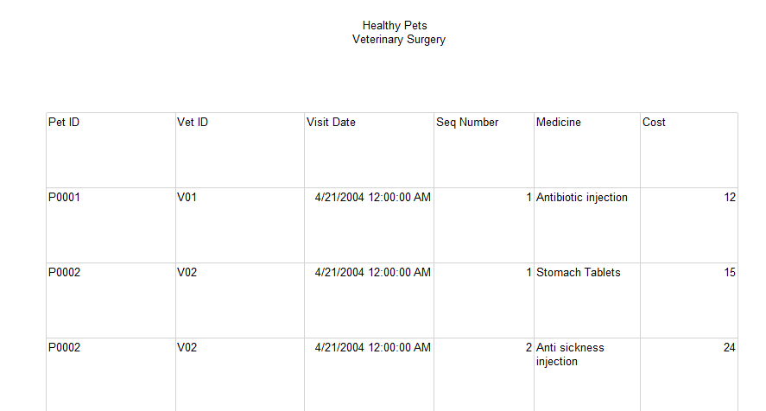

i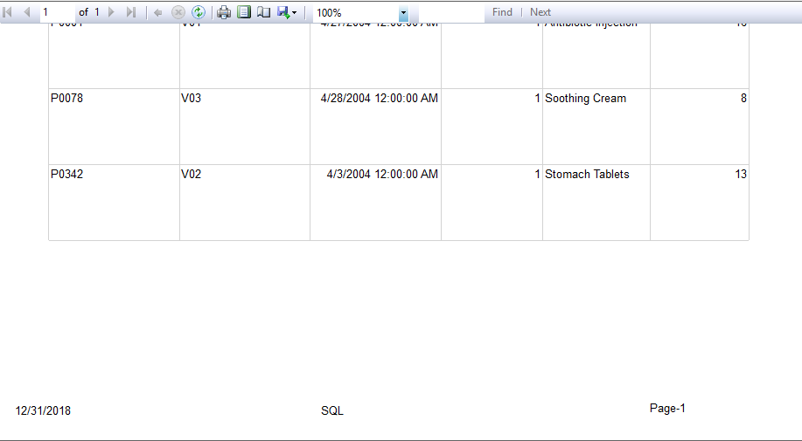

As the task requested, I creates a table to get a report.Then, I put 6 columns into the table. And, I gave the column anme from the dataset. I put the data into the data source1. And, as a result ,I got the table for the report.

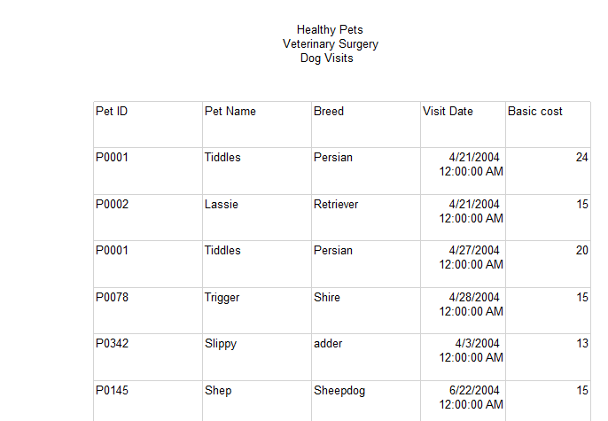



The task said that I need ton give a second report. So, I created a table into the sql tools. I made 5 columns inn the table.And I put the data into the table from dataset. And, I used datasource 2 for this table.And the task said I need to sum the total cost of the basic cost.So,I sum the total cost and put it in the table.As a result,I got the table for Dog visits.